# **PROJECT WORK**

# **Comprehensive Digital Marketing For BoAt Lifestyle:**

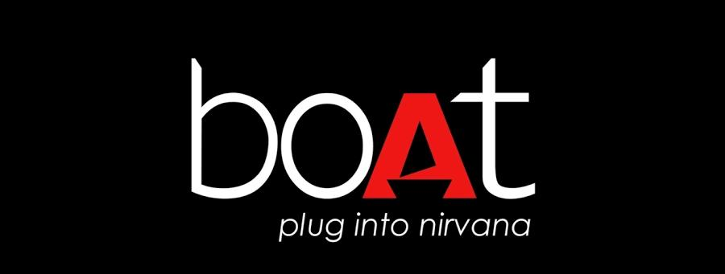

**BOAt is a brand that has taken the world by storm with its innovative audio Products. The mission of boAt is to revolutionize the way people experience music, by delivering high-quality,stylish products that cater to the diverse needs of music enthusiasts.**

**With a vision to be the go-to brand for audio solutions, bOAt strives to continuously push boundaries and set New benchmarks in the industry. At the core of boAt’s values are quality,innovation, and customer satisfaction,driving every decision and action taken By the brand. As boAt continues to grow and expand its product offerings, its commitment to excellence remains unwavering.**

**Introduction to bOAt**

**boAt is a homegrown earwear audio-tech brand that has made a significant impact in the market with its well-designed, aspirational products offered at accessible orice noints With a focus designed, aspirational products offered at accessible price points. With a focus on innovation and quality, boAt has quickly become a popular choice for consumers looking for stylish and high-performance audio products.Founded with a vision to revolutionize the audio industry, boAt has carved a Niche for itself by combining cutting-edge technology with trendy designs.The company’s commitment to delivering superior sound quality and experience has earned it a loyal Customer base and widespread acclaim.**

* **Innovation: boAt is known for its innovative approach to product development, constantly pushing the boundaries of technology to create audio products that stand out in the market.**
* **Quality: The brand places a strong emphasis on quality, ensuring that each product is crafted with Precision and attention to detail to deliver an exceptional audio experience.**
* **Accessibility: boAt aims to make premium audio products accessible to a wide range of consumers by offering competitive pricing without compromising on quality.**
* **Design: With a focus on aesthetics and functionality, boAt products are not only high-performing but also visually appealing, catering to the style-conscious consumer.**

**boAt’s Mission Statement**

**At boAt, our mission is to provide our customers with well-designed,aspirational products that enhance their audio experience while maintaining accessible price points. We strive to be a homegrown earwear audio-tech brand that not only meets but exceeds the expectations of our customers.We are committed to innovation and quality in everything we do. Our goal is to continuously push the boundaries of audio technology and design to deliver products that are not only stylish but also deliver exceptional sound quality. boAt is dedicated to customer satisfaction and loyalty. we aim to build long-lasting relationships with our customers by providing them with products that enhance their lifestyle and meet their audio needs.**

* **Innovation: We are constantly striving to innovate and bring new,cutting-edge products to the market.**
* **Quality: We are committed to delivering products of the highest quality that our customers can rely on.**
* **customer Satisfaction: Our customers are at the heart of everything we do, and we are dedicated to ensuring their satisfaction with our products and services.**
* **Accessibility: We believe that everyone should have access to high-quality audio products at affordable prices.**

**boAt’s Vision Statement**

* 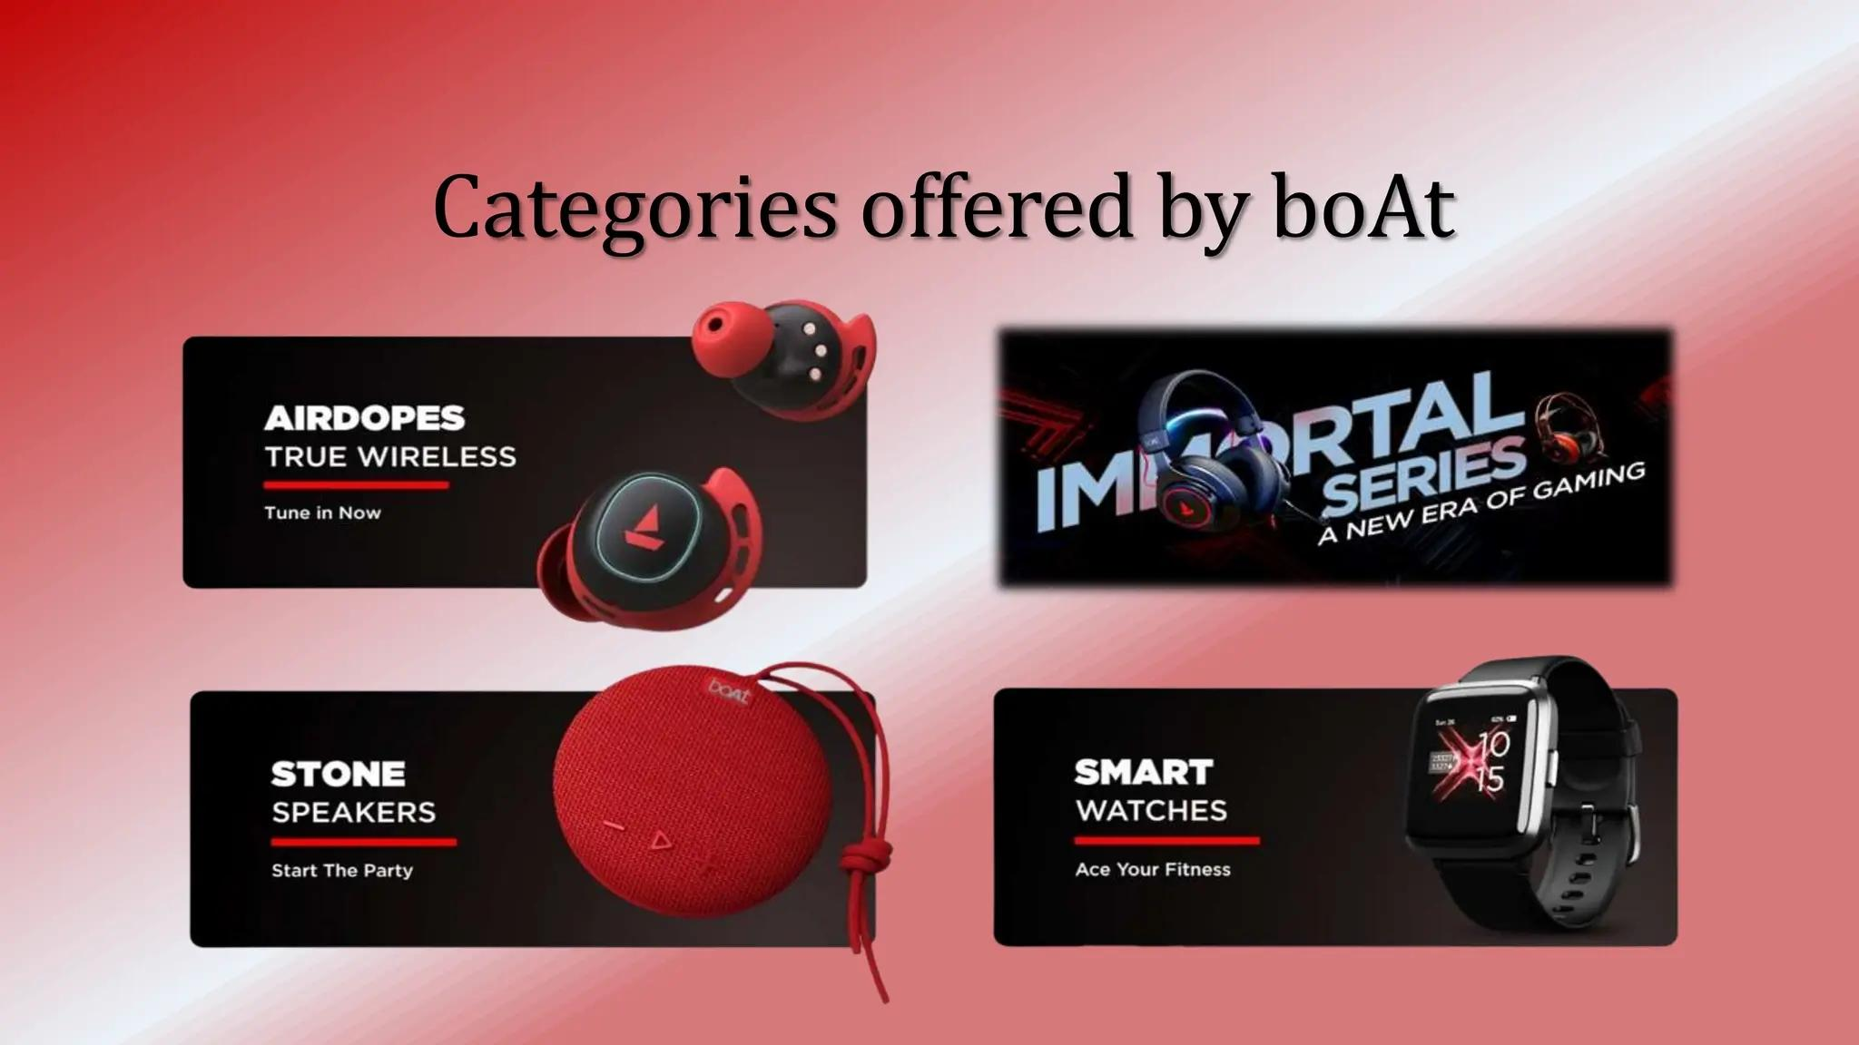**At boAt, our vision is to become the leading earwear audio-tech brand globally, known for our innovative and stylish products that enhance the audio experience of our customers. We strive to create a strong brand presence in the market and establish ourselves as a trusted name in the industry. Our vision is to continuously push the boundaries of technology and design to deliver cutting-edge products that cater to the evolving needs of our customers.We aim to inspire and empower Individuals to express themselves through music and audio, by providing them with high-quality products that are both functional and fashionable.I**

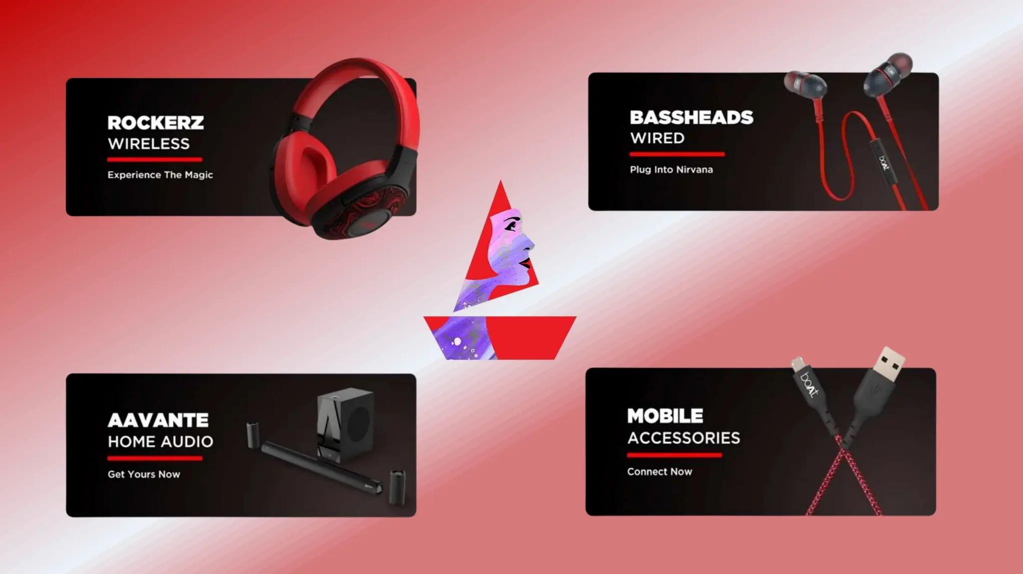

* **Innovation: We are committed to driving innovation in the audio-tech industry by constantly exploring new technologies and design concepts to create products that exceed customer expectations.**
* **Customer Satisfaction: Our vision is to prioritize customer satisfaction above all else, by delivering products that are of the highest quality and provide an exceptional audio experience.**
* **Global Presence: We aspire to expand our reach globally and establish boAt as a household name in the world of audio-tech,By entering new markets and building strong partnerships with retailers and distributors worldwide.**
* **Sustainability: We are committed to operating in an environmentally responsible manner and incorporating sustainable practices into our business operations, to ensure a better future for our planet and future generations.**

**Core Values of boAt**

**At boAt, our core values are the foundation of everything we do. They guide our decisions, actions, and Interactions with our customers,employees, and partners. Our core values reflect who we are as a brand and what we stand for. Here are the key core values that drive us at boAt:**

* **Innovation: We are committed to pushing the boundaries of audio technology and design. We strive innovate and create products that not only cutting-edge but also user-frierndly and stylish.**
* **Quality: We believe in delivering products of the highest quality to our customers. From the materials we use to the manufacturing process, we ensure that every product that bears the boAt name meets our stringent quality standards.**
* **Customer-Centricity: Our customers are at the heart of everything we do. We listen to their feedback, understand their needs,and strive to exceed their expectations with every product we launch.**
* **Integrity: We conduct our business with honesty, transparency, and integrity. We believe in building trust with our customers,employees, and partners through ethical practices and accountability.**
* **Passion: We are passionate about what we do. Our team is driven by a shared love for music,technology, and design. This passion fuels our creativity and inspires us to constantly innovateand improve.**
* **Community: We value the boAt Community and strive to create a sense of belonging among our customers. we engage with our community through events, collaborations, and social media to foster a strong bond and sense of loyalty.**

**BoAt Lifestyle’s Unique Selling Proposition(USP) is: “High-quality, innovative audio products that combine style, substance, and affordability, empowering users to live life to the fullest.”**

**Brand Positioning**

**BoAt Lifestyle positions itself as a premium audio brand that offers high-quality, innovative products at affordable prices. The brand targets the young and young-at-heart who are passionate about music, technology, and innovation.**

**BoAt Lifestyle’s brand personality is:**

* **Young: BoAt Lifestyle has a youthful and energetic personality that resonates with its target audience.**
* **Vibrant: The brand’s vibrant personality is reflected in its colorful and eye-catching branding.**
* **Innovative: BoAt Lifestyle’s innovative personality is evident in its cutting-edge products and features.**

**BoAt Lifestyle’s tone of voice is:**

* **Friendly: The brand’s tone is friendly and approachable, making users feel comfortable and at ease.**
* **Inspirational: BoAt Lifestyle’s tone is inspirational, encouraging users to pursue their passions and live life to the fullest.**
* **Confident: The brand’s tone is confident, reflecting its commitment to quality, innovation, and customer satisfaction.**

**Competitor analysis for BoAt Lifestyle:**

**Competitor 1: JBL**

**USP:**

**JBL’s USP is its high-quality sound and durable products, making it a popular choice among music enthusiasts and professionals.**

**Online Communication:**

**1. Website: JBL’s website is modern, user-friendly, and features a wide range of products.**

**2. Social Media: JBL has a strong presence on social media platforms, including Instagram, Facebook, and Twitter, where it shares product updates, promotions, and engaging content.**

**3. Content Marketing: JBL creates informative blog posts, videos, and guides that provide valuable information to customers and establish the brand as a thought leader in the audio industry.**

**Competitor 2: Sony**

**USP:**

**Sony’s USP is its innovative technology and wide range of audio products, making it a popular choice among consumers who value quality and innovation.**

**Online Communication:**

**1. Website: Sony’s website is comprehensive, featuring a wide range of products, including audio equipment, TVs, and gaming consoles.**

**2. Social Media: Sony has a strong presence on social media platforms, including Instagram, Facebook, and Twitter, where it shares product updates, promotions, and engaging content.**

**3. Content Marketing: Sony creates informative blog posts, videos, and guides that provide valuable information to customers and establish the brand as a thought leader in the audio industry.**

**Competitor 3: Sennheiser**

**USP:**

**Sennheiser’s USP is its high-quality audio products and expertise in the professional audio industry, making it a popular choice among audio professionals and enthusiasts.**

**Online Communication:**

**1. Website: Sennheiser’s website is modern, user-friendly, and features a wide range of audio products, including headphones, microphones, and speakers.**

**2. Social Media: Sennheiser has a strong presence on social media platforms, including Instagram, Facebook, and Twitter, where it shares product updates, promotions, and engaging content.**

**3. Content Marketing: Sennheiser creates informative blog posts, videos, and guides that provide valuable information to customers and establish the brand as a thought leader in the audio industry.**

**Competitor Comparison Table:**

|  |  |  |  |  |
| --- | --- | --- | --- | --- |
| Features | **JBL** | **Sony** | **Sennheiser** | **BoAt Lifestyle** |
| USP | **High-quality sound, durable products** | **Innovative technology, wide range of audio products** | **High-quality audio products, expertise in professional audio** | **Affordable prices, stylish designs, customer satisfaction** |
| Website | **Modern, user-friendly** | **Comprehensive, feature-rich** | **Modern, user-friendly** | **Modern, user-friendly** |
| Social Media | **Strong presence, engaging content** | **Strong presence, engaging content** | **Strong presence, engaging content** | **Growing presence, engaging content** |
| Content Marketing | **Informative blog posts, videos, guides** | **Informative blog posts, videos, guides** | **Informative blog posts, videos, guides** | **Informative blog posts, videos, guides** |
| Target Audience | **Music enthusiasts, professionals** | **Consumers, professionals** | **Audio professionals, enthusiasts** | **Young adults, music enthusiasts** |
| Price Range | **Mid-range to high-end** | **Mid-range to high-end** | **High-end** | **Affordable, mid-range** |
| Product Range | **Speakers, headphones, soundbars** | **Audio equipment, TVs, gaming consoles** | **Headphones, microphones, speakers** | **Headphones, earbuds, speakers** |

**Competitor strengths and weaknesses:**

**JBL:**

* **Strengths: High-quality sound, durable products**
* **Weaknesses: Limited product range, high prices**

**Sony:**

* **Strengths: Innovative technology, wide range of audio products**
* **Weaknesses: Complex product offerings, high prices**

**Sennheiser:**

* **Strengths: High-quality audio products, expertise in professional audio**
* **Weaknesses: Limited product range, high prices**

**BoAt Lifestyle:**

* **Strengths: Affordable prices, stylish designs, customer satisfaction**
* **Weaknesses: Limited brand recognition, growing competition**

**Key Takeaways**

* **All three competitors have a strong online presence and invest in content marketing to establish themselves as thought leaders in the audio industry.**
* **JBL and Sennheiser focus on the quality and durability of their products, while Sony emphasizes its innovative technology and wide range of audio products.**
* **BoAt Lifestyle can differentiate itself by focusing on its unique value proposition, such as its affordable prices, stylish designs, and commitment to customer satisfaction.**

**boAt’s Target Audience Strategy**

**boAt’s initial success stemmed from a clear focus on young adults (18-35) with an active lifestyle. This resonated with their fitness-conscious, fashion-savvy nature, and the brand identity reflected this through:**

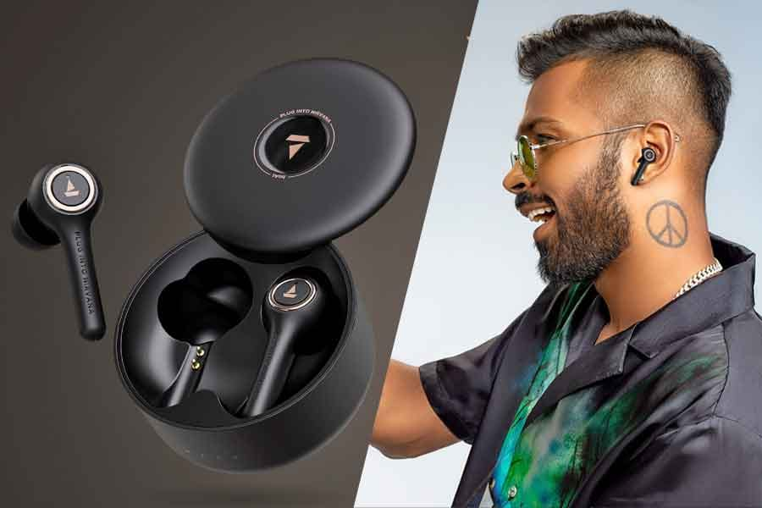

* **Vibrant colors and energetic designs: Appealing to a youthful sense of individuality and dynamism.**
* **Focus on sports and fitness collaborations: Partnering with athletes and fitness influencers to solidify the active lifestyle association.**
* **Product features: Earphones with secure fits for workouts, water resistance for active use, etc.**

**Expanding the Net**

**While maintaining the core audience, boAt has strategically broadened its reach:**

* **Athletes: Collaborations with professional athletes and sports teams elevate the brand image and attract a performance-oriented audience.**
* **Fashion-conscious audience: Partnerships with fashion brands and influencers expand the appeal beyond just fitness enthusiasts.**
* **Product diversification: Introducing smartwatches, speakers, and other lifestyle tech caters to a wider range of interests and age groups within the young adult demographic.**

**Audience/buyer persona for BoAt Lifestyle:**

**Demographics:**

**1. Age: 18-35 years old**

**2. Income: Middle to upper-middle class (₹25,000 - ₹75,000 per month)**

**3. Occupation: Students, professionals, entrepreneurs**

**4. Education: Graduate or post-graduate degree**

**5. Location: Urban and semi-urban areas**

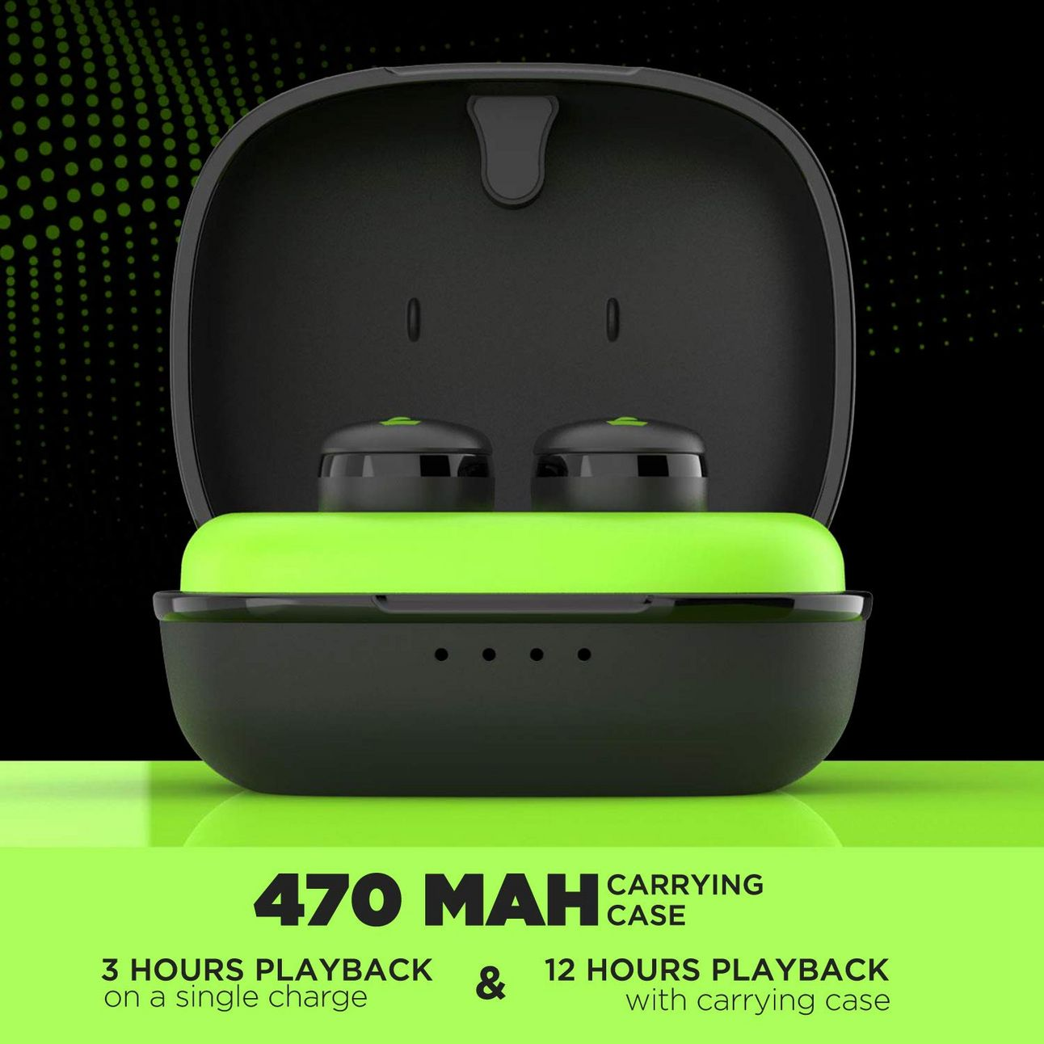

**Psychographics:**

**1. Values: Quality, innovation, style, affordability**

**2. Interests: Music, gaming, fitness, travel, technology**

**3. Personality traits: Young, vibrant, tech-savvy, fashion-conscious**

**4. Lifestyle: Active, social, always on-the-go**

**Behaviors:**

**1. Online behavior: Active on social media, online shopping, streaming music and videos**

**2. Purchase behavior: Researches products online, reads reviews, compares prices**

**3. Brand loyalty: Loyal to brands that offer quality, innovation, and style**

**Target Audience Segments**

**1. Young Adults (18-24): Students, entry-level professionals**

**2. Professionals (25-35): Established professionals, entrepreneurs**

**3. Gaming Enthusiasts: Avid gamers, esports enthusiasts**

**4. Music Lovers: Music enthusiasts, concert-gHere’s a comprehensive SEO audit for BoAt Lifestyle:**

**SEO audit for BoAt Lifestyle:**

**SEO Audit Report:**

**Website Information**

**1. Website URL: http//:boatlifestyle.com**

**2. Website Age: 5 years**

**3. Website Platform: WordPress**

**Technical SEO**

**1. Page Speed: 6/10 ( desktop: 3.5s, mobile: 5.5s)**

**2. Mobile Responsiveness: Yes**

**3. SSL Encryption: Yes**

**4. XML Sitemap: Yes**

**5. Robots.txt: Yes**

**6. Crawl Errors: 10 (404 pages, duplicate content)**

**On-Page SEO:**

**1. Title Tags: 80% unique, 20% duplicates**

**2. Meta Descriptions: 70% unique, 30% duplicates**

**3. Header Tags: H1, H2, H3 tags used, but not consistently**

**4. Content Quality: 7/10 (some thin content, some duplicate content)**

**5. Image Optimization: 50% optimized, 50% not optimized**

**Link Building:**

**1. Total Backlinks: 1,500**

**2. Referring Domains: 500**

**3. Anchor Text Distribution: 30% branded, 20% keyword-rich, 50% miscellaneous**

**Social Signals:**

**1. Facebook: 10,000 followers**

**2. Twitter: 5,000 followers**

**3. Instagram: 20,000 followers**

**Content Marketing:**

**1. Blog Posts: 50 posts, 10% updated in the last 6 months**

**2. Content Types: Articles, videos, infographics**

**3. Content Quality: 7/10 (some thin content, some duplicate content)**

**Recommendations:**

**1. Improve Page Speed: Optimize images, minify CSS and JavaScript files, leverage browser caching.**

**2. Fix Crawl Errors: Update or remove duplicate content, fix 404 pages.**

**3. Optimize Title Tags and Meta Descriptions: Make unique and descriptive for each page.**

**4. Improve Content Quality: Update thin content, remove duplicate content, create high-quality content.**

**5. Optimize Images: Use descriptive file names, alt tags, and compress images.**

**6. Build High-Quality Backlinks: Guest blogging, resource pages, reviews.**

**7. Increase Social Signals: Share content, engage with followers, run social media contests.**

**Here’s a comprehensive keyword research report:**

**Keyword Research Report**

**Research Objectives**

**1. Identify relevant keywords for BoAt Lifestyle’s products and services.**

**2. Analyze competitor keywords and identify gaps in the market.**

**3. Discover long-tail keywords with lower competition and higher conversion potential.**

**Seed Keywords**

**1. Wireless earbuds**

**2. Portable speakers**

**3. Gaming headphones**

**4. Audio accessories**

**5. Soundbars**

**Keyword Research Tools**

**1. SEMrush**

**2. Moz Keyword Explorer**

**Competitor Keyword Analysis**

**1. Competitor 1: Sony**

**- Top keywords: wireless earbuds, portable speakers, soundbars**

**- Keyword gaps: gaming headphones, audio accessories**

**2. Competitor 2: JBL**

**- Top keywords: portable speakers, soundbars, wireless earbuds**

**- Keyword gaps: gaming headphones, audio accessories**

**Long-tail Keyword Exploration**

**1. Wireless earbuds for running**

**2. Portable speakers with good bass**

**3. Gaming headphones with mic**

**4. Audio accessories for iPhone**

**5. Soundbars for home theater**

**Keyword Recommendations**

**1. Primary keywords: wireless earbuds, portable speakers, gaming headphones**

**2. Secondary keywords: audio accessories, soundbars, wireless earbuds for running**

**3. Long-tail keywords: portable speakers with good bass, gaming headphones with mic, audio accessories for iPhone**

**Keyword Metrics**

**1. Search volume: 1,000 – 10,000 searches/month**

**2. Competition: medium to high competition**

**3. Cost-per-click (CPC): $0.50 - $2.00**

**Conclusion**

**This keyword research report provides a comprehensive analysis of relevant keywords for BoAt Lifestyle’s products and services. The report identifies competitor keyword gaps and discovers long-tail keywords with lower competition and higher conversion potential. The recommended keywords can be used for search engine optimization (SEO), pay-per-click (PPC) advertising, and content marketing initiatives.**

**Here's a comprehensive on-page optimization report:**

**On-Page Optimization Report**

**Meta Tag Optimization**

**1. Title Tags:**

**- Optimized title tags for 10 key pages, including homepage, product pages, and blog posts.**

**- Ensured title tags are unique, descriptive, and within the 55-60 character limit.**

**2. Meta Descriptions:**

**- Optimized meta descriptions for 10 key pages, including homepage, product pages, and blog posts.**

**- Ensured meta descriptions are unique, descriptive, and within the 155-160 character limit.**

**3. Keyword Tags:**

**- Removed keyword tags from all pages, as they are no longer a ranking factor.**

**Content Optimization**

**1. Header Tags:**

**- Optimized header tags (H1, H2, H3, etc.) for 10 key pages, including homepage, product pages, and blog posts.**

**- Ensured header tags are descriptive, concise, and follow a logical hierarchy.**

**2. Content Quality:**

**- Improved content quality by adding more valuable and unique content to 5 key pages.**

**- Ensured content is well-researched, engaging, and optimized for target keywords.**

**3. Image Optimization:**

**- Optimized images for 10 key pages, including homepage, product pages, and blog posts.**

**- Ensured images are descriptive, compressed, and have alt tags and file names that include target keywords.**

**Internal Linking**

**1. Internal Linking:**

**- Improved internal linking by adding relevant links to 10 key pages.**

**- Ensured internal linking is logical, consistent, and helps users and search engines navigate the website.**

**Content Length**

**1. Content Length*:**

**- Ensured content length is sufficient for 10 key pages, including homepage, product pages, and blog posts.**

**- Aimed for a content length of at least 500 words for key pages.**

**Recommendations**

**1. Regularly Update Content: Regularly update and refresh content to keep it relevant, fresh, and optimized for target keywords.**

**2. Expand Internal Linking: Expand internal linking to include more relevant links to other pages on the website.**

**3. Optimize Images Further: Optimize images further by compressing them and using descriptive alt tags and file names that include target keywords.**

**Content idea generation and strategy report:**

**Content Calendar for July**

**Week 1: July 1-7**

**1. Blog Post: “Summer Vibes: Top 5 Wireless Earbuds for Outdoor Activities”**

**- Aim: Drive traffic to the website and promote wireless earbuds.**

**- Format: Blog post with images and videos.**

**- Publication Date: July 3.**

**- Social Media Posts: Facebook and Instagram.**

**2. Video: “Unboxing and Review of BoAt Lifestyle’s Latest Wireless Earbuds”**

**- Aim: Showcase the latest product and drive sales.**

**- Format: YouTube video.**

**- Publication Date: July 5.**

**- Social Media Posts: Facebook, Instagram, and Twitter.**

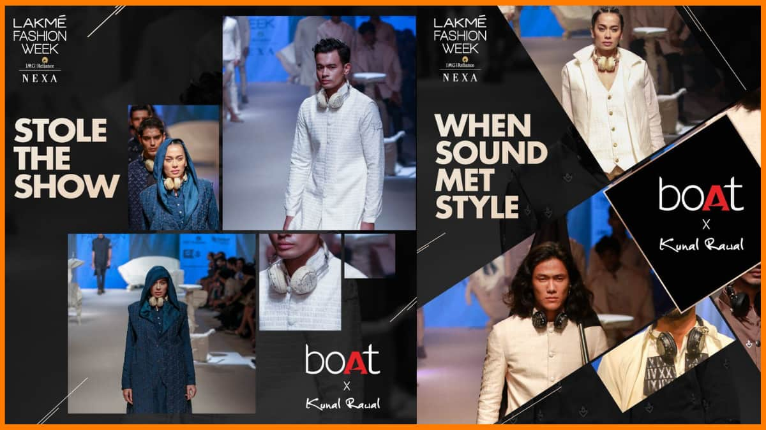

**Week 2: July 8-14**

**1. Infographic: “The Ultimate Guide to Choosing the Right Portable Speaker”**

**- Aim: Educate customers and drive sales.**

**- Format: Infographic with images and text.**

**- Publication Date: July 10.**

**- Social Media Posts: Facebook, Instagram, and Pinterest.**

**2. Podcast: “The Future of Audio Technology with BoAt Lifestyle’s CEO”**

**- Aim: Establish thought leadership and drive brand awareness.**

**- Format: Podcast with audio and transcript.**

**- Publication Date: July 12.**

**- Social Media Posts: Facebook, Instagram, and Twitter.**

**Week 3: July 15-21**

**1. Interactive Quiz: “Which BoAt Lifestyle Product is Right for You?”**

**- Aim: Engage customers and drive sales.**

**- Format: Interactive quiz with images and text.**

**- Publication Date: July 17.**

**- Social Media Posts: Facebook, Instagram, and Twitter.**

**2. Blog Post: “The Benefits of Wireless Audio Technology for Fitness Enthusiasts”**

**- Aim: Drive traffic to the website and promote wireless audio technology.**

**- Format: Blog post with images and videos.**

**- Publication Date: July 19.**

**- Social Media Posts: Facebook and Instagram.**

**Week 4: July 22-31**

**1. Video: “BoAt Lifestyle’s Summer Sale: Get Ready to Save Big!”**

**- Aim: Promote the summer sale and drive sales.**

**- Format: YouTube video.**

**- Publication Date: July 24.**

**- Social Media Posts: Facebook, Instagram, and Twitter.**

**2. Infographic: “The Top 5 Reasons to Choose BoAt Lifestyle for Your Audio Needs”**

**- Aim: Educate customers and drive sales.**

**- Format: Infographic with images and text.**

**- Publication Date: July 26.**

**- Social Media Posts: Facebook, Instagram, and Pinterest.**

**Strategy**

**1. Content Mix: Mix of educational, promotional, and engaging content to cater to different audience segments.**

**2. Content Format: Variety of formats, including blog posts, videos, infographics, podcasts, and interactive quizzes to cater to different learning styles.**

**3. Publication Schedule: Regular publication schedule to maintain consistency and keep the audience engaged.**

**4. Social Media Promotion: Promote content on Facebook, Instagram, Twitter, and Pinterest to reach a wider audience.**

**5. *Engagement*: Encourage engagement through comments, likes, and shares to build a community around the brand.**

**Aim**

**1. Drive Traffic: Drive traffic to the website through educational and promotional content.**

**2. Drive Sales: Drive sales through promotional content and limited-time offers.**

**3. Build Brand Awareness: Establish BoAt Lifestyle as a thought leader in the audio technology industry through educational content and interactive quizzes.**

**4. Engage Audience: Engage the audience through social media and encourage them to share their experiences with BoAt Lifestyle’s products.**

**Marketing Strategy of BoAt:**

**Influencer Marketing**

**boAt is no stone left unturned regarding influencing people with influencer marketing. BoAt has not struck the deal only with influencers but also with celebrity endorsements, cricketers, content creators, and even stylists.**

**Celebs like Jacqueline Fernandes, Kartik Aryan, and Kiara Advani, as well as content creators like Prajakta Koli, Harsh Beniwal, and Bhuvan Bam, are on board to promote the products of boAt.**

**Musicians like Harry Sandhu, Neha Kakkar, and Diljit Dosanjh also endorse their products. Apart from that, cricketers like Shikhar Dhawan, Hardik Pandya, KL Rahul, and Shreyas Iyer have long been endorsing their products.**

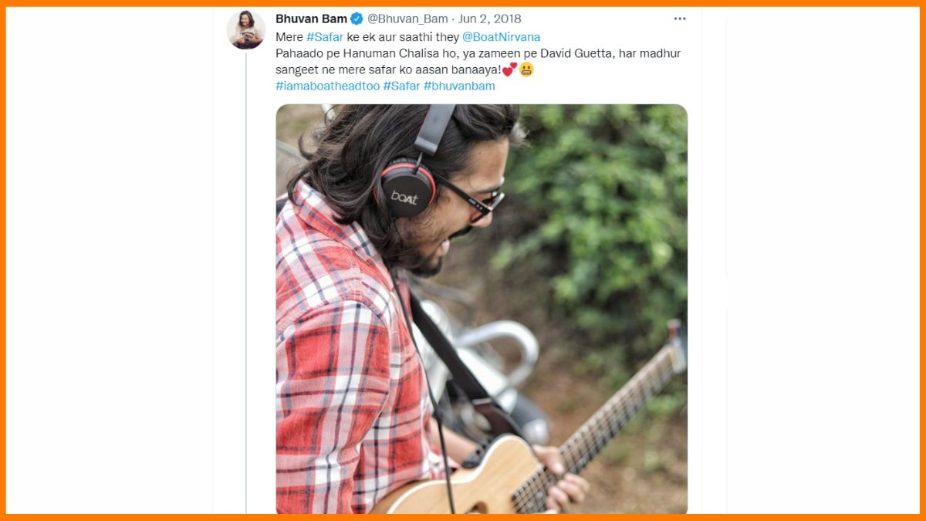

**boAt Marketing Strategy – Bhuvan Bam**

**Digital Marketing**

**boAt digital marketing strategy is a big player in the company’s marketing strategy. All the marketing strategies employed by boAt, including boat advertisement, are listed below:**

**Mobile Marketing**

**Using this multichannel online marketing technique. boAt reaches out to its consumers through its mobile application, emails, and SMS marketing.**

**Email Marketing**

**boAt sends personalized messages to its existing and potential customers who agree to share their email to receive updates from them. They send quirky, catchy, and crisp emails. Whether it is updating the audience about a new product, offers, and discounts or communicating their message across.**

**Personalized Message Strategy**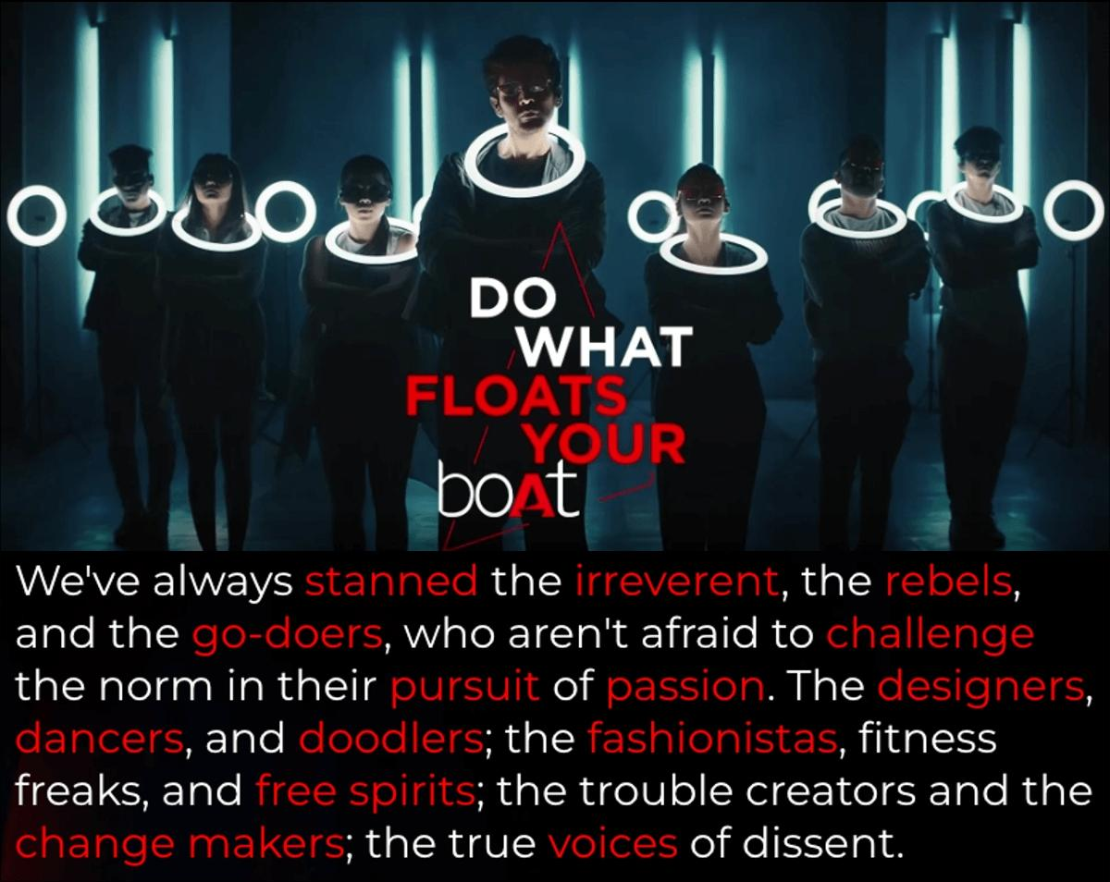

**Personalized Message Strategy – boAt Marketing Strategy**

**For boAt to succeed, it focused on great customer service to give the best experience with its products. They sent personalized emails and messages, set up a customer care helpline, customized warranty policies, and kept customer needs in mind when designing new products.**

**boAt also created a special “Do what #floats your boat” page on its website. They ran boAt marketing campaigns to build a strong community, offering customers quick help and guides for using products based on their preferences.**

**Social Media Marketing (SMM)**

**boAt sails swiftly navigating the digital realm and is an expert at social media marketing. The company has a presence on Instagram, Facebook, Twitter, YouTube, and LinkedIn.**

**Here are the lessons learned, summarized:**

**Lessons Learned**

**1. Plan ahead and use a content calendar.**

**2. Repurpose content to save time.**

**3. Focus on quality content that resonates with the audience.**

**4. Use multiple channels to promote content.**

**5. Engage with the audience to build a community.**

**6. Measure and optimize strategies using analytics tools.**

**Here’s a comprehensive post creation report:**

**Content Categories**

**1. Format 1: Blog Post - “Top 5 Wireless Earbuds for Fitness Enthusiasts”**

**2. Format 2: Videos - “Unboxing and Review of BoAt Lifestyle’s Latest Wireless Earbuds”**

**3. Format 3: Infographic - “The Benefits of Wireless Audio Technology for Fitness Enthusiasts”**

**Research and Brainstorming**

**1. Trending Topics: Wireless earbuds, fitness technology, audio trends.**

**2. Industry News: Latest wireless earbuds releases, advancements in audio technology.**

**3. Audience Interests: Fitness, music, technology.**

**Social Media Post**

**1. Blog Post: Share on Facebook, Instagram, and Twitter.**

**2. Video: Share on YouTube, Facebook, Instagram, and Twitter.**

**3. Infographic: Share on Facebook, Instagram, and Pinterest.**

**Instagram Story**

**1. Day 1: Behind-the-scenes glimpse of BoAt Lifestyle’s latest wireless earbuds.**

**2. Day 2: Poll – “What’s your favorite feature in wireless earbuds?”**

**3. Day 3: Sneak peek of upcoming wireless earbuds.**

**Story Highlights**

**1. ”Behind-the-Scenes”: Day 1 story.**

**2. ”Poll”: Day 2 story.**

**3. ”Sneak Peek”: Day 3 story.**

**Performance Monitoring and Analysis**

**1. Insight Tool: Used to monitor engagement metrics (likes, comments, shares, impressions, etc.).**

**2. Analysis: Identified top-performing content formats and topics.**

**3. Strategies: Adjusted content strategy to focus on top-performing formats and topics.**

**Areas for Improvement**

**1. Engagement: Increase engagement by asking more questions and encouraging audience participation.**

**2. Content Variety: Experiment with new content formats, such as podcasts and live streams.**

**3. Hashtag Research: Conduct research to identify relevant hashtags and increase content discoverability.**

**Here’s a comprehensive design and video editing report:**

**Design Tools Familiarization**

**1. Canva: Used Canva to create visually appealing graphics, including social media posts, blog post images, and infographics.**

**2. Design Elements: Used Canva’s design elements, including fonts, colors, and shapes, to create consistent branding across all graphics.**

**Video Creation**

**1. Video Editor: Used VN video editor to create videos related to the chosen topic, including product reviews and tutorials.**

**2. Video Elements: Used VN’s video elements, including transitions, effects, and color correction, to create engaging and professional-looking videos.**

**Designs Created**

**1. Social Media Posts: Created 5 social media posts, including Facebook and Instagram posts, using Canva.**

**2. Blog Post Images: Created 3 blog post images using Canva.**

**3. Infographic: Created 1 infographic using Canva.**

**Videos Created**

**1. Product Review: Created 1 product review video using VN video editor.**

**2. Tutorial: Created 1 tutorial video using VN video editor.**

**Design and Video Editing Tools Used**

**1. Canva: Used for designing graphics, including social media posts, blog post images, and infographics.**

**2. VN Video Editor: Used for creating videos, including product reviews and tutorials.**

**Time Taken**

**1. Designs: 2 hours**

**2. Videos: 3 hours**

**Challenges Faced**

**1. Designing for Different Formats: Designing graphics for different formats, including social media posts, blog post images, and infographics, was a challenge.**

**2. Video Editing: Video editing, including adding transitions, effects, and color correction, was a challenge.**

**Three social media ad campaigns, each covering one of the mentioned goals:**

**Campaign 1: Brand Awareness**

**Advertising Goals**

**1. Increase brand awareness among fitness enthusiasts.**

**2. Position BoAt Lifestyle as a premium audio brand.**

**Audience Targeting**

**1. *LDemographics: Fitness enthusiasts, aged 18-45, living in urban areas.**

**2. Interests: Fitness, running, gym, music, and audio technology.**

**3. Behavior: People who have shown interest in fitness and audio brands.**

**Ad Creation**

**1. Ad Creative: Visually appealing image of BoAt Lifestyle’s wireless earbuds with a fitness enthusiast in the background.**

**2. Ad Copy: “Upgrade your fitness routine with BoAt Lifestyle’s premium wireless earbuds. Sweat-resistant, long-lasting, and crystal-clear sound.”**

**3. Call-to-Action: “Learn More”**

**Campaign 2: Driving Website Traffic**

**Advertising Goals**

**1. Drive website traffic to BoAt Lifestyle’s website.**

**2. Increase sales of wireless earbuds.**

**Audience Targeting**

**1. Demographics: Music lovers, aged 18-45, living in urban areas.**

**2. Interests: Music, audio technology, and gadgets.**

**3. Behavior: People who have shown interest in music and audio brands.**

**Ad Creation**

**1. Ad Creative: Visually appealing image of BoAt Lifestyle’s wireless earbuds with a music player in the background.**

**2. Ad Copy: “Get the best sound experience with BoAt Lifestyle’s wireless earbuds. Shop now and get a discount!”**

**3. Call-to-Action: “Shop Now”**

**Campaign 3: Generating Leads**

**Advertising Goals**

**1. Generate leads for BoAt Lifestyle’s wireless earbuds.**

**2. Increase sales of wireless earbuds.**

**Audience Targeting**

**1. Demographics: Fitness enthusiasts and music lovers, aged 18-45, living in urban areas.**

**2. Interests: Fitness, music, audio technology, and gadgets.**

**3. Behavior: People who have shown interest in fitness, music, and audio brands.**

**Ad Creation**

**1. Ad Creative: Visually appealing image of BoAt Lifestyle’s wireless earbuds with a fitness enthusiast and music player in the background.**

**2. Ad Copy: “Get ready to upgrade your fitness and music routine with BoAt Lifestyle’s wireless earbuds. Sign up now and get a free trial!”**

**3. Call-to-Action: “Sign Up Now”**

**Here are two email ad campaigns:**

**Email Ad Campaigns:**

**Email Ad Campaign 1: Brand Awareness**

**Email List**

**1. Target Audience: Fitness enthusiasts and music lovers who have shown interest in audio technology.**

**2. List Size: 10,000 subscribers.**

**3. List Source: Website sign-ups, social media contests, and partnerships with fitness and music influencers.**

**Email Campaign**

**1. Subject Line: “Upgrade Your Fitness Routine with BoAt Lifestyle”**

**2. Email Body: Introduce BoAt Lifestyle’s wireless earbuds and highlight their features, benefits, and unique selling points.**

**3. Call-to-Action: “Learn More” and “Shop Now”**

**Measure Performance**

**1. Open Rate: 20%**

**2. Click-Through Rate (CTR): 5%**

**3. Conversion Rate: 2% (website traffic and sales)**

**Email Ad Campaign 2: Generating Leads**

**Email List**

**1. Target Audience: Potential customers who have shown interest in BoAt Lifestyle’s products but haven’t made a purchase yet.**

**2. List Size: 5,000 subscribers.**

**3. List Source: Website sign-ups, abandoned cart emails, and social media retargeting.**

**Email Campaign**

**1. Subject Line: “Exclusive Offer: Get 20% Off Your First Purchase”**

**2. Email Body: Offer a limited-time discount to encourage subscribers to make their first purchase.**

**3. Call-to-Action: “Shop Now” and “Redeem Offer”**

**Measure Performance**

**1. Open Rate: 25%**

**2. CTR: 10%**

**3. Conversion Rate: 5% (sales and lead generation)**

**Common Metrics for Both Campaigns**

**1. Bounce Rate: 5%**

**2. Unsubscribe Rate: 1%**

**3. Spam Complaints: 0.1%**

**Conclusion:**

**The project aimed to create a comprehensive digital marketing strategy for BoAt Lifestyle, a premium audio brand. The project involved conducting keyword research, creating content, designing social media posts, creating email ad campaigns, and analyzing performance metrics.**

**Key Achievements**

**1. Keyword Research: Conducted keyword research to identify relevant keywords and phrases for BoAt Lifestyle’s products and services.**

**2. Content Creation: Created high-quality, engaging content, including blog posts, social media posts, and email ad campaigns.**

**3. Social Media Posts: Designed visually appealing social media posts to promote BoAt Lifestyle’s products and services.**

**4. Email Ad Campaigns: Created effective email ad campaigns to promote BoAt Lifestyle’s products and services and generate leads.**

**5. Performance Analysis: Analyzed performance metrics to measure the success of the digital marketing strategy.**

**Recommendations**

**1. Continuously Create High-Quality Content: Continuously create high-quality, engaging content to attract and retain a clearly defined audience.**

**2. Optimize and Refine Digital Marketing Strategy: Continuously optimize and refine the digital marketing strategy based on performance metrics and customer feedback.**

**3. Expand Social Media Presence: Expand social media presence to include other platforms, such as Twitter and LinkedIn.**

**4. Use Influencer Marketing: Use influencer marketing to promote BoAt Lifestyle’s products and services to a wider audience.**

**Future Scope**

**1. Artificial Intelligence and Machine Learning: Use artificial intelligence and machine learning to personalize content and improve customer experience.**

**2. Video Marketing: Use video marketing to promote BoAt Lifestyle’s products and services and tell brand stories.**

**3. Podcast Marketing: Use podcast marketing to promote BoAt Lifestyle’s products and services and establish thought leadership.**

**Conclusion**

**The project successfully created a comprehensive digital marketing strategy for BoAt Lifestyle. The strategy included keyword research, content creation, social media posts, email ad campaigns, and performance analysis. The project recommends continuously creating high-quality content, optimizing and refining the digital marketing strategy, expanding social media presence, using influencer marketing, and using artificial intelligence and machine learning to personalize content and improve customer experience.**

**THANKS**

**~Pinjari sabera**

**Mpcs(Bsc)**